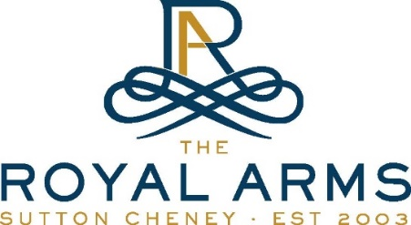
Valentine’s Day
4 Courses £39.95 per head / Bookings only / 01455 290263

Starters
Parsnip Veloute, Truffle (V) (GF)
Chicken Lollipop, Pea, Quail Egg
Duck Liver Parfait, Spiced Plum, Toasted Brioche

Heritage Carrot, Beetroot, Root Vegetable Crisps, Goats Curd
(CAN BE MADE VEGAN)

Palate Cleanser
Gin & Grapefruit Sorbet

Mains
Beef Wellington For 2; Pomme Puree, Baby Veg, Red Wine Jus
Seared Duck Breast, Leg Bonbon, Potato Terrine, Red Cabbage
Cod, Spiced Lentils, Onion, Potato
Nuts about you Butternut Squash Risotto, Parmesan, Pine Nuts, Rocket
Desserts
Love you Berry Much Lemon & Blueberry Cheesecake, fruit coulis, fresh berries
Sexy Chocolate Tart, Balsamic Strawberries, Sorbet
Stuck on my mind Sticky Toffee Pudding
3 Cheese Platter to share

